Working with images in Word Documents
There is so much you can do by adding images to Word documents or asking your learners to do the same. Images can be used to illustrate a process, to evidence something, to enliven a document or as a basis for testing.
These students were asked to find vacant premises which would be suitable for starting their small business. I asked for photographic evidence of their research to be included in their word processed business plan​
Here we will add a sequence of photos to a word document in order to illustrate a process or technique. I have the images saved in my images folder.
If you wish to edit your images in some way (eg: cropping, increasing the brightness or fixing red eye, right click on the image and select “open with” and then either “Microsoft Office Picture Manager” or “Windows Live Photo Gallery”. Either of these will allow you to improve or resize your images.
See below.​
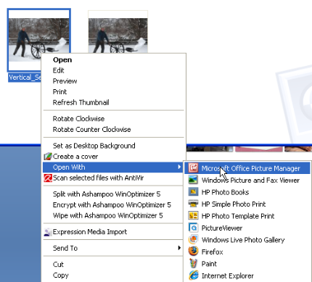
In Picture Manager, select Edit Pictures​
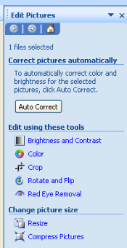
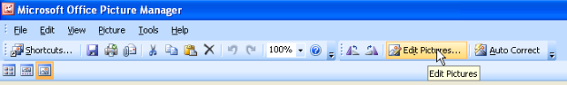
Choose your tool as desired.
Remember to save your changes when you have finished editing your picture!

Open a new Word document.
Here, I am using Word 2007 but all the principles are the same for older versions of Word.
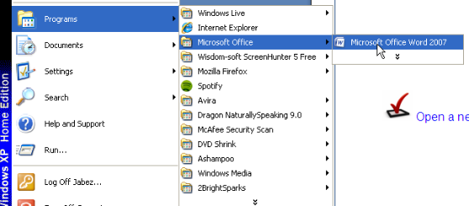
Add Your Title​
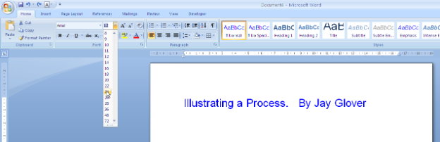
Write your Introduction​
Click the “Insert” Tab and then select “Picture”​
​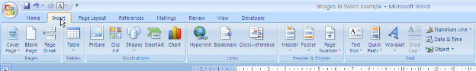

Browse for your picture, highlight it with a left mouse click and then click “Insert”.​
​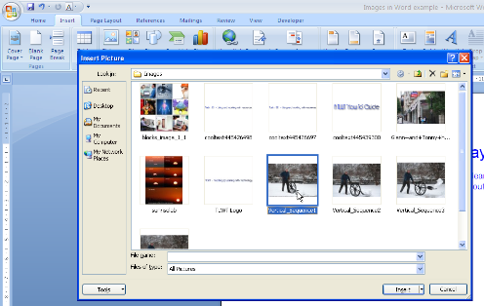
Your Image will now appear in the Word document. In a moment we will write some explanatory text….. but first we might want to re-size the image.
Re-Size any picture in Word by “dragging” the “anchor points” at the corners of the image until you reach the desired size
This is the size I want:​
I will now add more text.
As this is a sequence, I have added the text “Step 1”. I now want to “wrap” my explanatory text so that it appears next to, rather than above or below the image.
Right click the image
Select “Text Wrapping”
Choose “Tight”
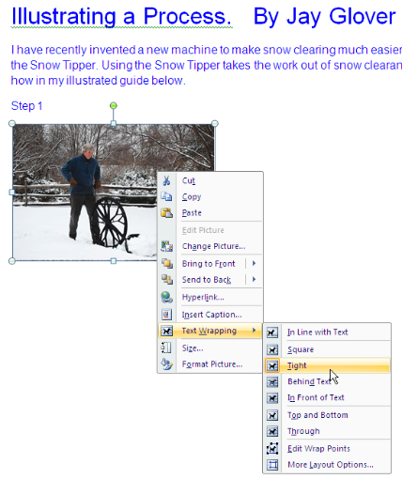
Position the cursor at the top and to the right of the image and type your text.​​
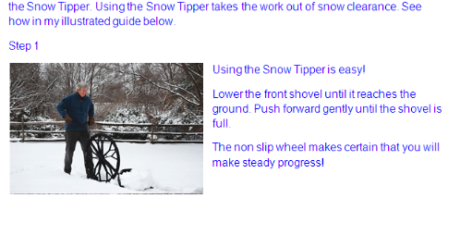

I can now simply repeat the process when adding additional images.
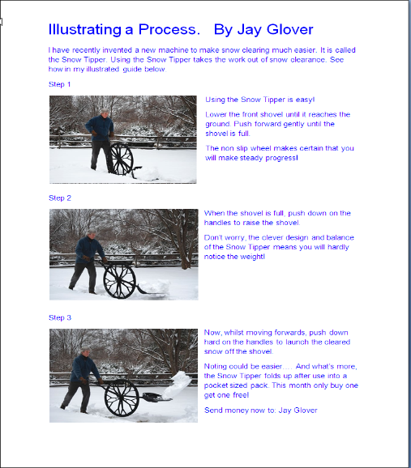
​​Watch how to use images in MS Word​
Give me feedback on this guide and/ or Screenr Guide

